
Teacher: Mrs. Cathy Dyson email: cdyson@evdio.org April 30 – May 6, 2018

CLASSROOM WEB PAGE: http://mrsdysons4thgradeclassroom.weebly.com/

THIS WEEK’S NEWS



Religion
~We will continue our viewing of the movie, Jesus of Nazareth. We should be close to finishing it this week and taking a quiz on it.
~There will be mass on Tuesday and Thursday this week. Remember that Thursday is Giving Day, so bring your church envelope!
~We will continue being the cantors and response singers for mass. We would love to have you join us!



Language Arts
~We will continue with our regular studies (using the Anthology, Reader’s / Writer’s workshop book, and Practice workbook.
~We will focus on expository text in a story called Why Does the Moon Change Shape?. Our skills will focus on ASK AND ANSWER QUESTIONS, CAUSE AND EFFECT, EXPOSITORY TEXT, CONTEXT CLUES, PRONOUNS, and HOMOPHONES.
~Our weekly test will cover the story, skills we learned this week, and the spelling list. The test will occur on Friday.

~Please continue to work on AR goals (book level, points, and comprehension). Remember it is essential to read outside of the classroom in order to meet your goals. No quizzes can be taken outside of the school hours or at other places. If any quizzes are, they will not count as part of meeting your goal. This will be a Language Arts test grade for our 4th grading period. AR goals need to be met by May 18th.


Science
~We will continue with our studies on Unit 4 – Energy and Ecosystems. We will learn what makes up a food chain and food web.



Social Studies
~We will continue with our study on Chapter 5. We will focus on THE NEW DEAL, WORLD WAR II, the COLD WAR, KOREAN, and VIETNAM WAR.
~Our Social Studies link on my weebly page, under Social Studies, should connect with our workbook. Please use that link for your Math website access also.


YOU SHOULD HAVE RECEIVED AN EMAIL (LAST FRIDAY) WITH A LINK TO THE VIDEO THEY MADE OF OUR PROJECT. PLEASE REMEMBER NOT TO SHARE THIS ON SOCIAL MEDIA. THANKS!!

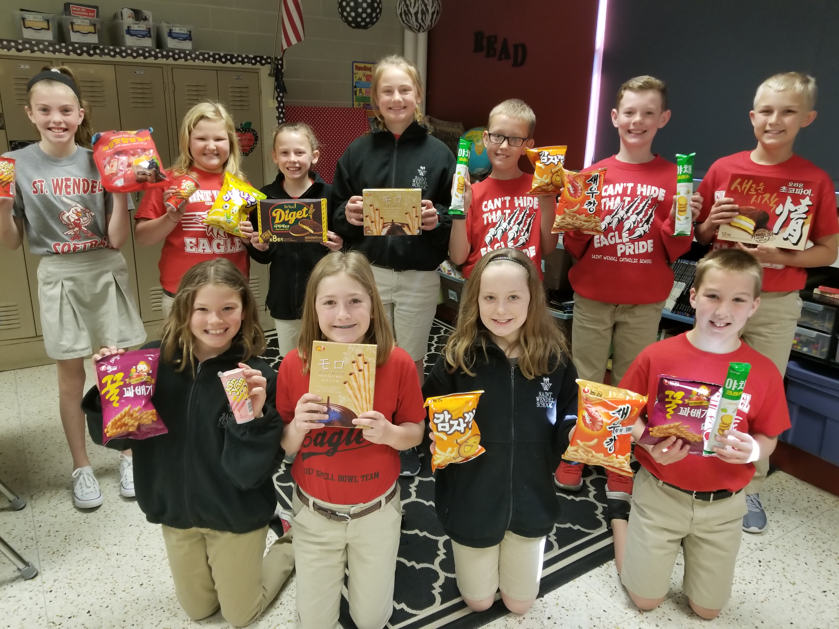

GOODIES FROM SOUTH KOREA!!! THANKS TO ONE OF OUR MILITARY STATIONED THERE –
2ND LIEUTENANT CHRISTOPHER ZIGA
WHAT A NEAT TREAT, WITH INTERESTING TASTES!!!

OUR SCHEDULE THIS WEEK:

MONDAY – MUSIC CLASS

TUESDAY – MASS

MUFFINS WITH MOM FOLLOWING MASS

GYM CLASS

WEDNESDAY – ART CLASS

THURSDAY - MASS

GYM CLASS

FRIDAY – FREE DRESS DAY

UNIT 4 WEEK 4 LANGUAGE ARTS TEST

ART CLASS

LIBRARY



PLEASE DON’T HESITATE TO CONTACT ME IF YOU HAVE ANY QUESTIONS OR CONCERNS.
MY EMAIL IS CDYSON@EVDIO.ORG AND MY CELL PHONE IS 812-457-3579 (receives texts too). I WILL RETURN A MESSAGE OR CONTACT YOU ASAP.
THANKS!!!

