
Teacher: Mrs. Cathy Dyson email: cdyson@evdio.org September 18 - 22, 2017

CLASSROOM WEB PAGE: http://mrsdysons4thgradeclassroom.weebly.com/

THIS WEEK’S NEWS



Religion
~This week we will continue with our studies with Chapter 2 this week. We will finish up Chapter 2 this week and be ready for our 1st Religion test next week.
Please make sure you check out my weebly page, on the Religion tab to study with study guides and games for review. I will also have the Beatitudes on the test and “blank out” on some words where the students will have to fill in the missing words. Start studying now.
~We will be attending mass on Tuesday and Thursday (Giving Day- bring envelope) this week.
~Our completed Beatitudes are now hanging up in the hallway, by the Girls Restroom, downstairs.



Language Arts
~We continue with our regular weekly studies this week. We will use our Reader’s / Writer’s Workshop book, our Anthology, and Practice Workbook. Our skills will focus on REREAD, MAIN IDEA AND KEY DETAILS, PERSUASIVE ARTICLE, SUFFIXES, and RUN-ON SENTENCES. The weekly test will cover those skills, our anthology story’s vocabulary and comprehension on the story, Kids in Business, and our spelling words. Please review them all in order to be prepared. A copy of your child’s spelling words was sent home with them last Friday. Please make sure your child looks over them. The test will occur on Friday.
~Don’t forget to continue reading to meet your AR goals also. Goals need to be met by Thursday, October 5th.


Science
~This week we continue our studies with inferencing, inferring, observing, comparing, communicating, hypothesizing, drawing conclusions, classifying and ordering, measuring, using time and space, and recording and displaying data.
~We do our next experiment – Pendulum Swing this week. We will focus on collecting data and measuring tools scientists use.



Social Studies
~We will continue with our studies covering Indiana’s vegetation, and animals from our state.
~Review worksheets and a Study Guide came home last week. Please see your child’s agenda book for details. The test on Chapter 1 will be on Wednesday this week.
~We may even begin learning some of our 50 states and capitals by using flash cards and silly stories to make learning fun. Ask us about our progress!!!



OUR SCHEDULE THIS WEEK:

MONDAY – MUSIC CLASS

TUESDAY – MASS

GYM CLASS

COMPUTERS

SOCIAL STUDIES REVIEW WORKSHEETS DUE

SPELL BOWL 2:35 – 3:10 (GRADE 3 ROOM)

WEDNESDAY - ART CLASS

CHAPTER 1 SOCIAL STUDIES TEST
SPELL BOWL 2:35 – 3:10 (GRADE 4 ROOM)

THURSDAY – CHURCH - bring envelope
COMPUTERS
GYM CLASS
SPELL BOWL 2:35 – 3:10 (GRADE 4 ROOM)

FRIDAY – SPIRIT DRESS DAY

UNIT 1 WEEK 5 LANGUAGE ARTS TEST

ART CLASS

LIBRARY



PLEASE DON’T HESITATE TO CONTACT ME IF YOU HAVE ANY QUESTIONS OR CONCERNS.
MY EMAIL IS CDYSON@EVDIO.ORG AND MY CELL PHONE IS 812-457-3579 (receives texts too). I WILL RETURN A MESSAGE OR CONTACT YOU ASAP.
THANKS!!!

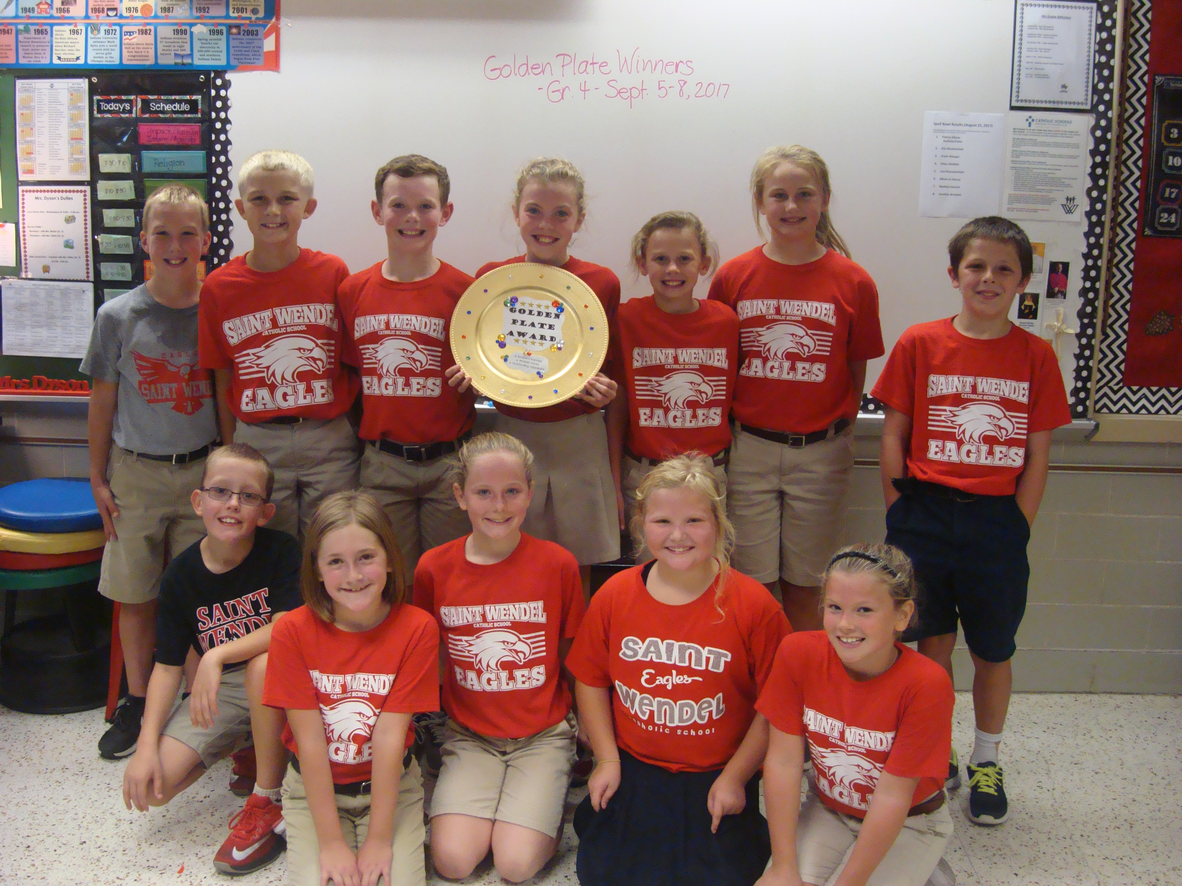

GOLDEN PLATE AWARD – LOWER GRADE COMPETITION FOR THE BEST CLASS AT LUNCH
WE GOT IT LAST WEEK!!!

